
Faculty of Humanities

Study guide for effective revision
Retrieval practice.
Spaced practice.
Elaboration.
Dual coding.
The Five Step study plan.
Key words glossary.

1.What is retrieval practice?
“Retrieval practice is a learning strategy where we focus on getting information out. Through the act of retrieval, or calling information to mind, our memory for that information is strengthened and forgetting is less likely to occur. Retrieval practice is a powerful tool for improving
learning.”
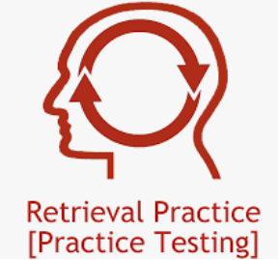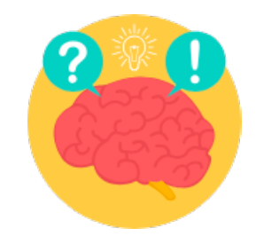

Use your class notes & textbooks to make a list of the important information & content that you need to know across different subjects.

Tips:
Create flashcards, complete quizzes to test yourself.
Retrieve as much information as you can.

Recommended to keep your cards into two sections. First, keep all your cards in the first box. If you can recall the information correctly, then place the card in box 2, if not, put it back in box 1. Continue to test yourself and each time you correctly recall information, place them. Eventually all your flashcards will be placed in the second box and the information they contain in your long-term memory!

Useful links:
https://classroom.remembermore.app/
A brilliant website with thousands of flashcards in a wide range of subjects.
https://ankiweb.net/shared/decks/
You need to download the available decks

The Leitner system:

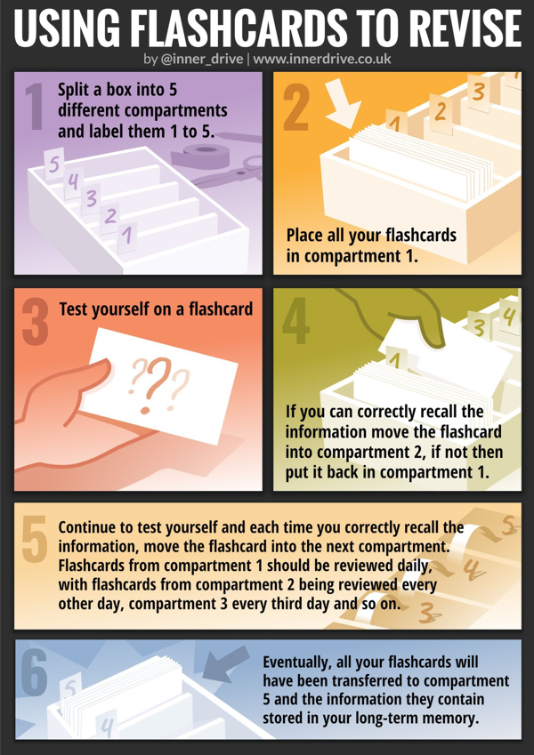
2. What is spaced practice?

“Start planning early for exams and set aside a little bit of time every day. Five hours spread out over two weeks is better than the same five hours all at once.” This is spaced practice & it is regarded as one of the most effective revision strategies.

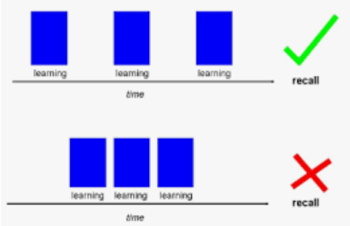

Tips:

Divide up your revision into short manageable chunks of time.

3. What is elaboration?

“The term elaboration can be used to mean a lot of different things. However, when we are talking about studying using elaboration, it involves explaining and describing ideas with many details. Elaboration also involves making connections among ideas you are trying to learn.”



Tips:
Elaboration involves asking further questions on certain topic and make links within that topic, so it helps you understand information more you already know.
Ask yourself questions about a topic to dig deeper. The more information you have about a specific topic the stronger ability to recall.

For example: in History:
Who was Hippocrates? What did he accomplish? What was his impact? What factors helped him?

4. What is dual coding?
“Dual coding is the process of combining verbal materials with visual materials. There are many ways to visually represent materials, such as with infographics, timelines, cartoon/comic strips, diagrams and graphic organisers.”

Tips:
Don’t worry if you don’t consider yourself an artist - it isn’t about the quality of your illustrations, the focus is to improve and deepen your understanding.
When reviewing something you have learnt, combining words and pictures can be powerful.
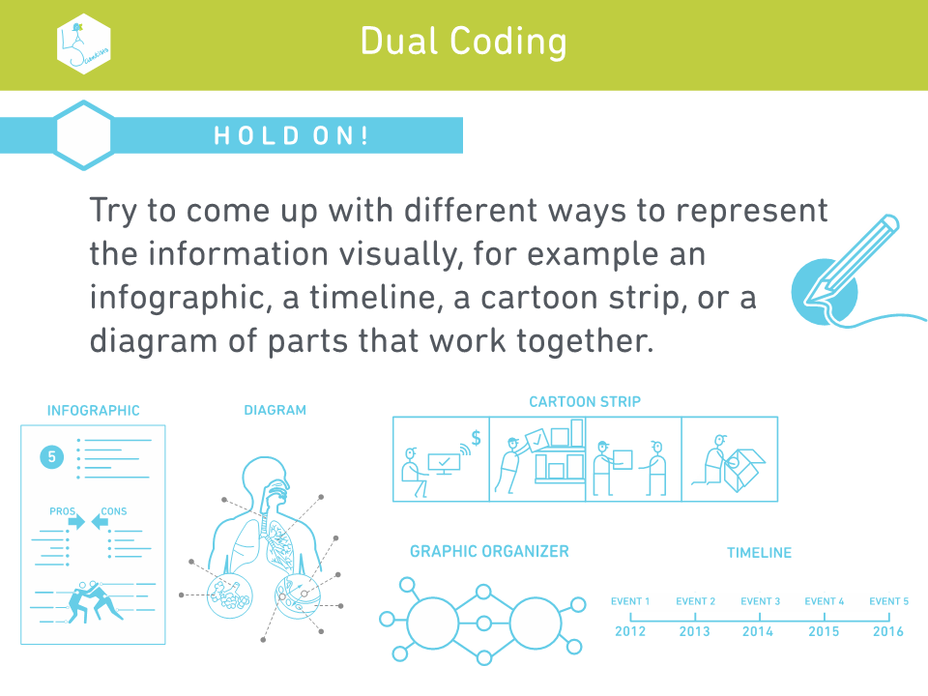
Examples:
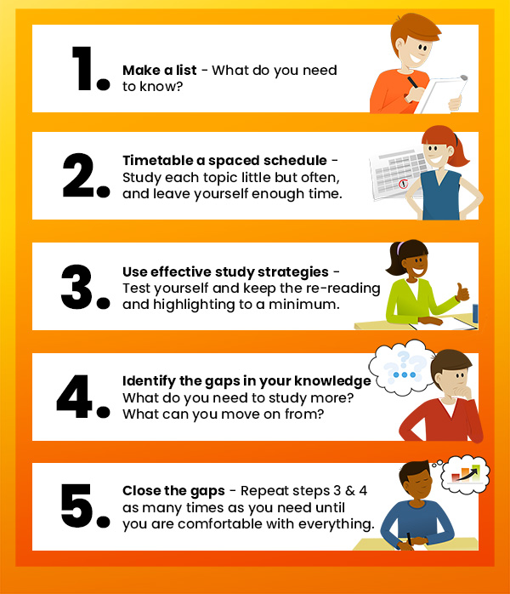
The Five Step Study Plan.

Exam words glossary:

Analyse - Examine something in detail and try to explain or interpret it.
Annotate - Add to a diagram, image or piece of text to illustrate or describe features rather than just identify them which is labelling.
Assess – Consider different options/arguments/factors and weigh them up to reach a conclusion about their effectiveness or validity.
Compare - Give a point by point identification of similarities and differences.
Define - This means what is meant by … give the precise meaning of a term or concept.
Describe - Provide an account in detail of an event/individual/concept etc.
Discuss - Set out both sides of an argument & reach a conclusion, including evidence.
Evaluate - Consider different options/factors & reach a conclusion about their importance/impact/value/worth.
Examine - Consider carefully & provide a detailed account of the topic.
Explain-Provide a detailed description or interpretation of a term/concept etc.
Identify - Point out & name from a number of possibilities.
Illustrate - Refer to a specific case study or example (not illustrate as in draw).
Label - Point out specific features on a diagram, image or piece of text.
Justify - Explain why your selected choice/judgement is better than other options.
Summarise - Sum up the main points/arguments this can be the similar to outline.

